**Overview of CSQ’s Schedule to Demand Optimization Engine**

**Prototype Details**

**Version : 1.0**

**Status : Draft**

**Summary :**

A challenge faced by all service providers is rapidly changing and fluid schedules caused by cancellations, no shows, mobility of the staff/service crew among other factors. CSQ's

AI-powered schedule-to-demand optimization engine addresses this problem by monitoring both the rapid changes and trends in provider’s schedule, translating them into real-time campaigns on popular social media sites.

This document aims at sharing the scope of the functionality that will be performed by the prototype being developed for the Demand Optimization Engine. It demonstrates the feasibility and simplicity of the product to be developed.

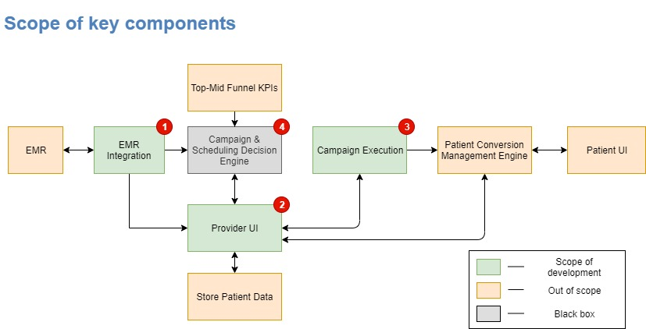

**Components of the prototype :**

**1. EMR Integration :** Open Dental EMR is widely used by dentists/dental providers in the US. The database used by Open Dental is MySQL. It contains dummy patients data. Trial version of the product is available without an expiry date. There are APIs available to access Open Dental. So currently, for this prototype Open Dental is to be used as the existing EMR.

* This component will explore the APIs and the data that can be obtained using these APIs.
* Also, whether these APIs are sufficient to get the required data for the prototype.

**2. Provider UI** : This UI displays three roles of users :

* Provider himself
* advertising agency of provider
* support staff

It communicates with the Campaign execution UI and provides the necessary parameters.

It also displays the following analytics : budget of campaign, actual amount spent, users who participated in the campaign, the outcome of campaign, new customers obtained.

**3. Campaign execution UI :** This component actually uploads the campaigns on different social media. Currently, for the prototype, Google Adwords and text campaigns are in scope. The campaigns will be executed using this component by making use of different parameters like geography, Cost per click, keywords to name a few. These parameters will be provided by the Provider UI.

**4. Campaign and Scheduling Decision engine** **(DE) :** This component is the core intelligence of the system. In the prototype that will be built, this component will be sending only recommendations to the Provider UI about possible campaigns that can be triggered. Development of a real decision logic is out of scope of this prototype.

Changes after pull request. 4:10 PM